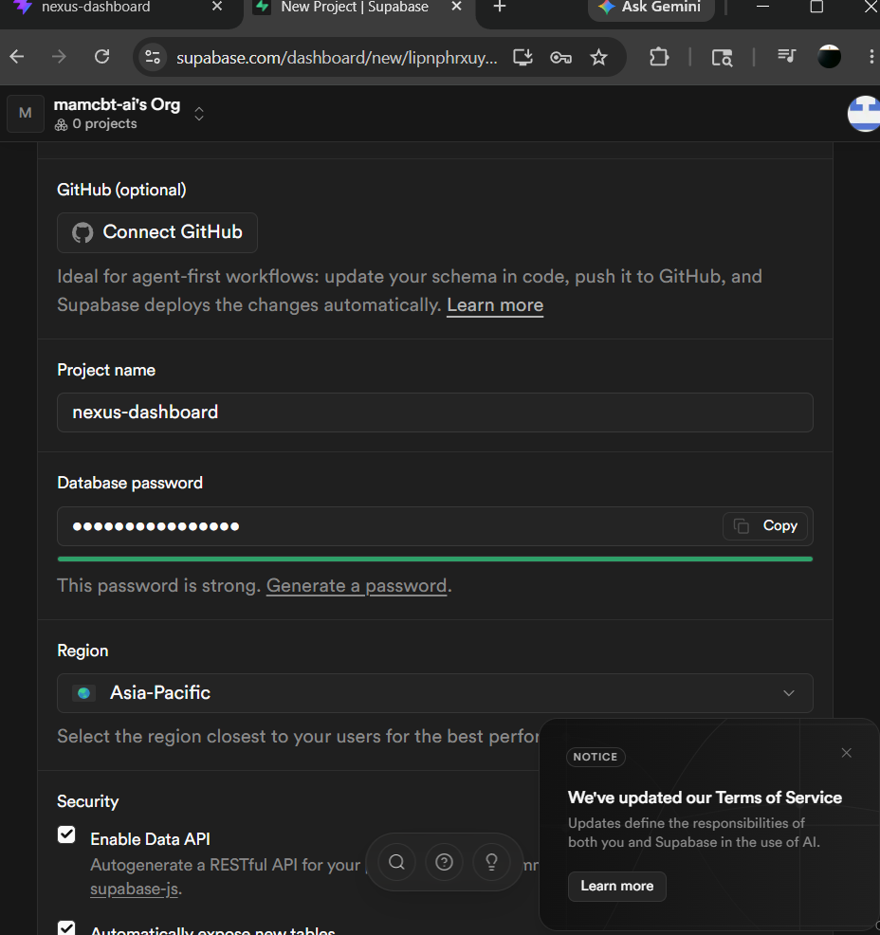

0SEh3VvTIjUNLwev

Google Cloud OAuth client created

Client ID : 538742372962-7ibaa3jtajfma84t1ptat3b9i48qqj6t.apps.googleusercontent.com
Client secret: 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
